A 4bid production

4 ways to go about it

Online 1-hour solo / duo sessions

Week 4
29.04.2020, h.12-13

Elisa – Irina

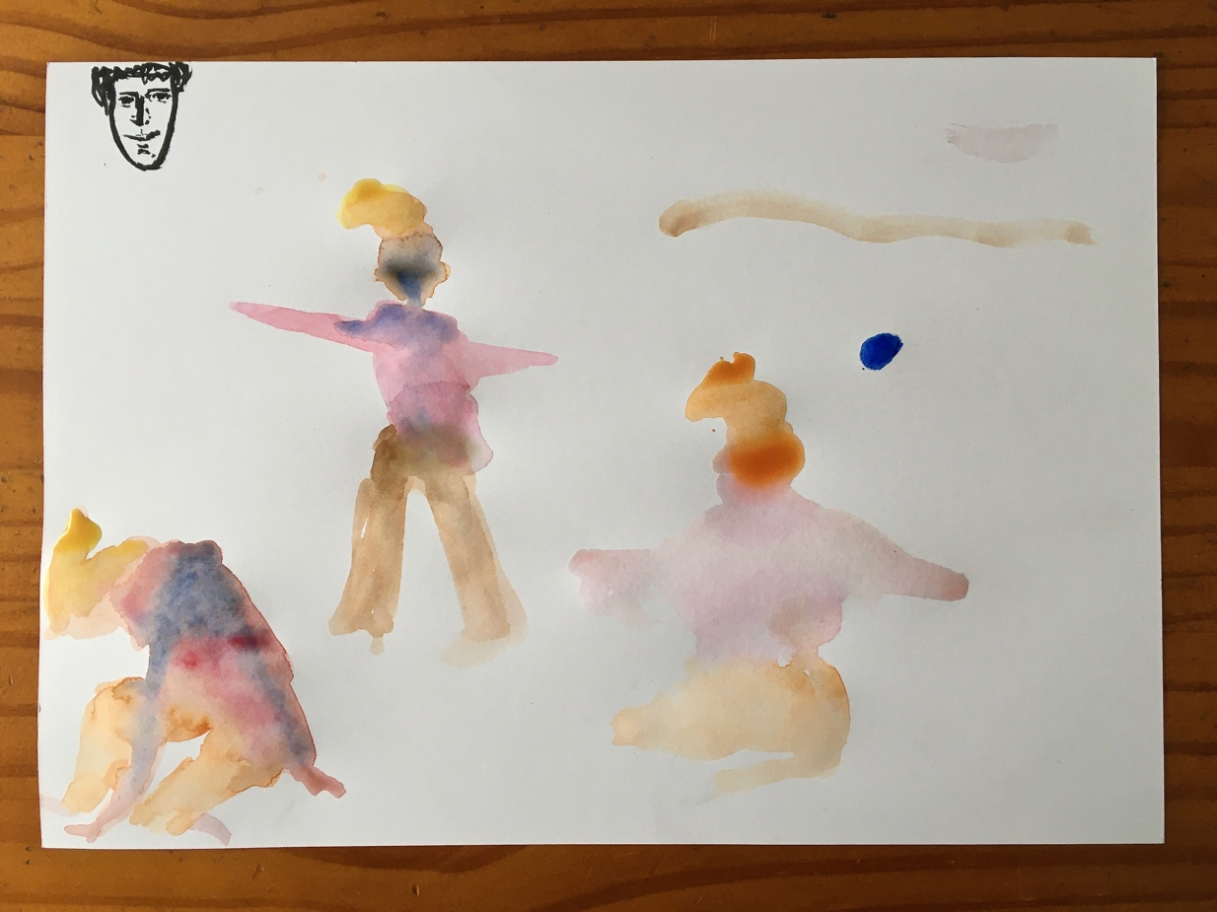

Watching “Neglection reversed” video.

I: take 3 mins to write down what you actually remembered about the video.

E: it’s more difficult than I thought!

I: interesting that you point it out. I showed it as an experiment yesterday and there was a lot of confusion and distorted elements emerged about what happened / what has been seen and heard / where was what.

E: maybe because you’re so into putting in doubt what’s happening and what happened that they overlap. There’s so much energy going on that at the end you’re are breathless.

I: for next time, I’d like to propose you to do a personal dramaturgy, with your own linearity, of what you’ve seen. You can choose to put one element in the foreground among text, movement or sound.

Task 1: shadow.

Write down impressions.

Task 2: contradictions, while you hear a text read by someone external to our group.

You can choose to get into your own contradiction(s) or get to the universal tasks:
Body parts – one effort
Two organs with one assigned quality each – dialogue

Write down impressions.

S: future futures

30.04.2020, h, 12 - 13

Artè – Charlie – Irina

Charlie: only video
Artè: only audio video: “Negligence: reversed”

Create your own dramaturgy of it, have a thought of a certain linearity. No deadline.
___________________________________________________________________

First task: shadow + speech played in background

Your own shadow towards / away from it. Either remember the past performed tasks experience or create a new one.

S: Charlie – flickering moments, experiencing being lost;
Artè – playing with shadow, something even got the impression is she the shadow herself? Different movements / exploring possibilities.

Second task: contradiction + Eli speaking in background

Your own contradiction, what it means to you.

After practice task: write down memories of the 2 tasks practiced today of movement + speech heard. Try to be as meticulous as possible about anything relevant for you. What’s the essential constitutive of these tasks?
What makes it, it?

I: both very deliberately walking in / out of tasks, like you know what is going on.

S: Charlie – alternating contradictions in fluid movements, less defined as if he’s not there, probably because part of his contradiction task is on thinking / not thinking, stopping / not stopping, cancelling things out, doing nothing / doing everything at the same time.
Artè – contradiction on every alternation of movement, as in 1 movement = 1 contradiction of it, endlessly executed, sharply defined.

01.05.2020, h.12-13

Tashi – Irina
Re-act
Transcription find our own narrative and linearity of video “Neglection:reversed”
Translation

First task: shadow + score in background (Eli)

Remember your own version of shadow towards / away

Take a minute to record impression of task

Second task: contradiction + score in background

Take a minute to record impression of task

For both task: set a matrix as detailed as possible regarding the politics, rhythmic, efforts that come with it, body design, in order to define what is it that makes this task, it? How much do I have to lose / add to make it, it?

T: my question that has arisen is: how can I break the linearity of perception?

S: shadow task – active play with shadow / be shadow in his own definition of 3D principle, shadow is also space around.
Contradiction task – puppet master of his own body as an outside Tashi forcing his own body of bending against his will / but it’s also him executing movement. Duality at same time. Voluntary slave.

