A 4bid production

4 ways to go about it

Online 1-hour quartet sessions

Week 3

21.04.2020, h.12 -13

Charlie – Tashi – Artè – Elisa

This week S. won’t be present to the live sessions due to work duties. Therefore, I.’s idea is to involve S. in feeding the loop with a task too. The sessions are sent in 2 different formats, audio only and video only. How does a personal experience change with an imposed glitch of a decomposed format? How can different ways of understanding (or misunderstanding or dis-understanding) a process be stimulated?
If the practice is seen as a big body (macro/ zoom out), it is not only one big body executing tasks but there’s more richness to it, embodied and enriched by the personality/ essence of everyone (micro/ zoom in), a production of atmo - spheres. Does it become a body with different version of itself? What’s the bare essence of this practice then?

VIDEO ONLY

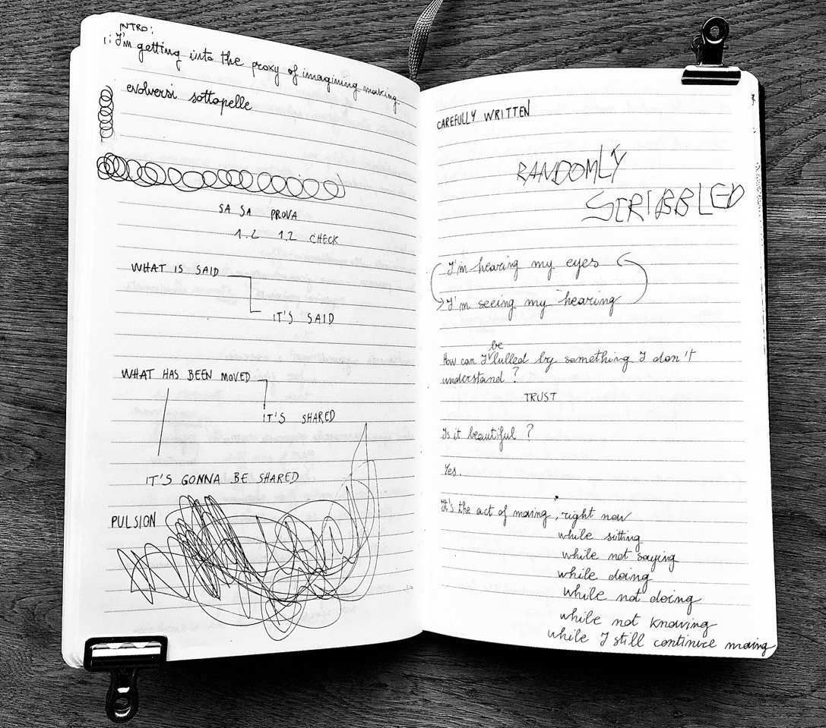
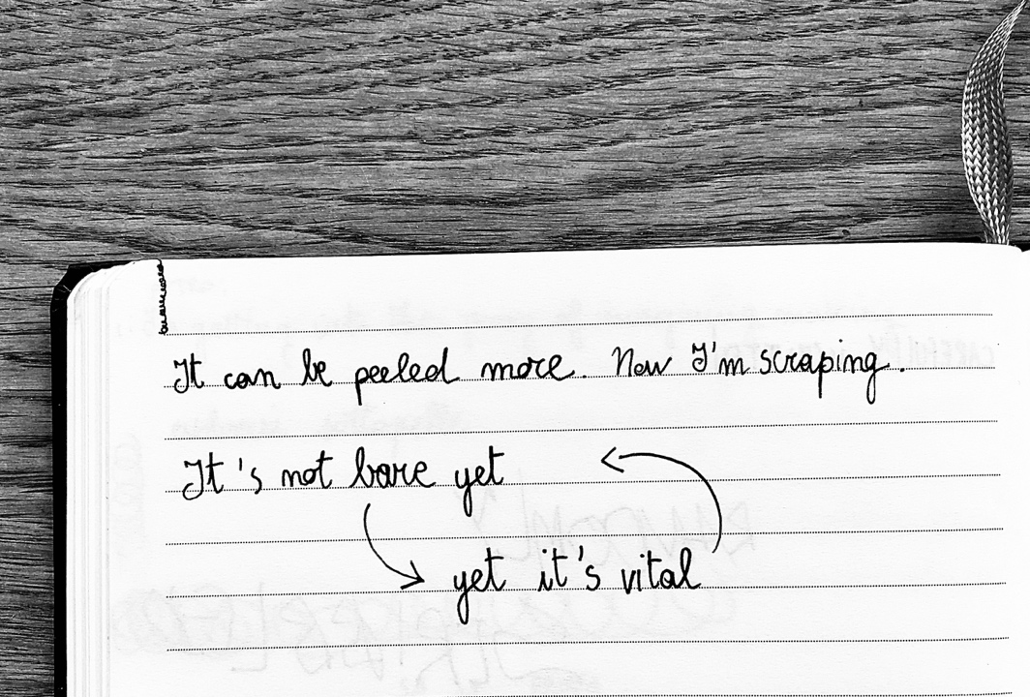

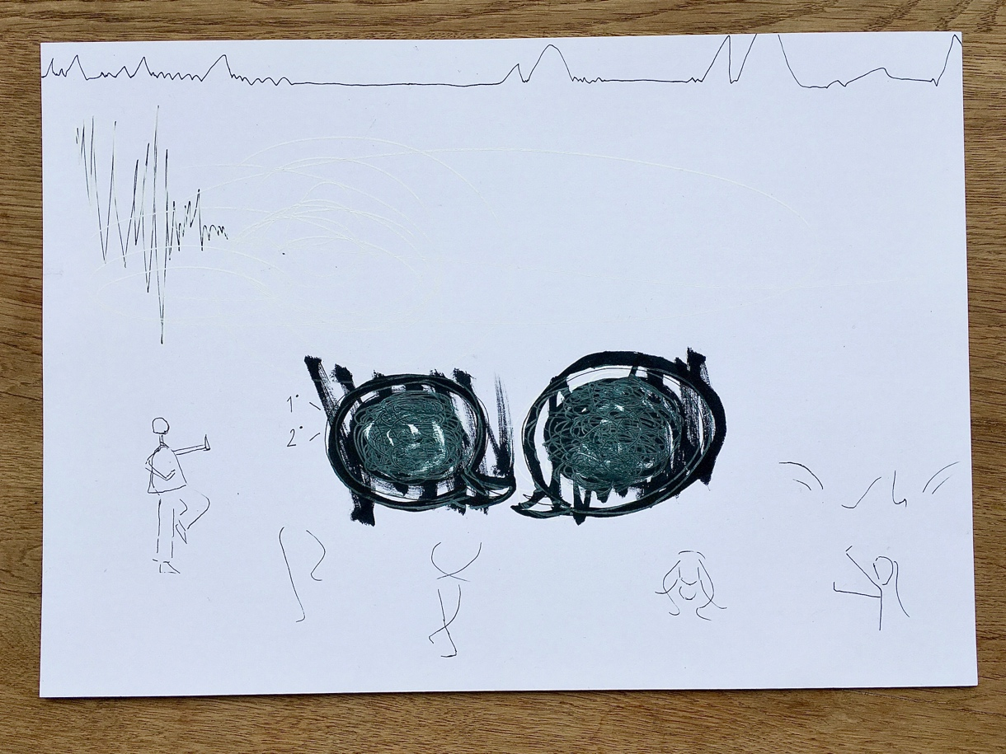
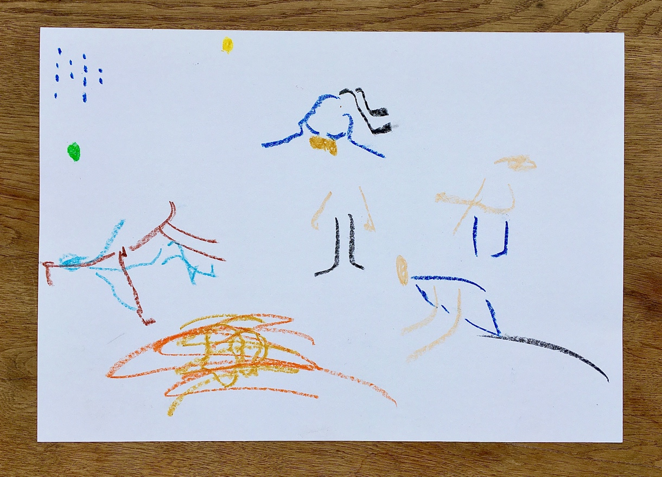

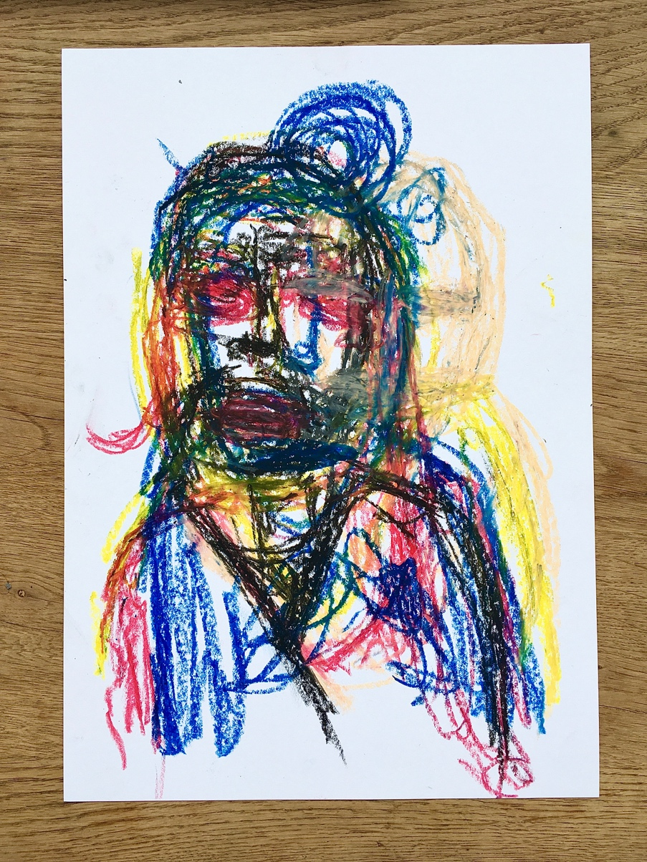

AUDIO ONLY

T: feedback loop, just let it be.
I: we all shape it in a direction in a different way.

Three tasks will make today’s practice. The focus will be on contradictions, shadows and eyes. It’ll be a mix of doing on your own and talking together.

Start with contradictions as a fusion with the work of the previous weeks done on your own and with somebody’s shadow.

Start with a body-mind warm up trying to figuring the contradiction out, not only as a thought.

What has been seen as starting creating by itself:
Dynamics
Hesitations
Decisiveness in unexpected moments
Search

Can you define it somehow?

Add layer: shadow moving towards/ away
Whatever shadow means to each of you.

What is this thinking that comes from the body?
Can the thought be a sense?
Can the stimulation of a thought define a practice?
Have a feeling in the thought to know what it is to change it.

C: I was playing with two contradictions: thinking / not
stopping / not.
I was flowing without the satisfaction of flow, kind of things cancelling out, the effort coming back and forth. I felt I could remain on this forever.

I: Add the shadow layer on this state.

I: As for the other 3 find previously felt experiences and add, but try not to deliberately impose layer: eyes.

Confuse you: Charlie moving towards eyes task;
Tashi stay with the eyes task;
Eli and Artè sharply shift to contradictions.

Moving on: Eli/ Tashi sharply towards shadows;
Artè stay on contradictions;
Charlie stay with eyes.

Moving on: Artè step back and join Charlie with the eyes;
Eli step forward and join Charlie and Artè with the eyes;
Tashi step back on contradictions.

Moving on all on contradictions with adding an element-in-space layer: an imaginary anchor on a directional line that provokes a push/ pull effect. If one direction pushes, the opposite pulls.

How are your movements? Repetitive?
Define what your contradiction is and relate it to the push/ pull direction.

Transition to eye task, gradually in sequence: Artè
Eli
Tashi
Charlie.

End of practice.

I: it’s beautiful to watch, elements of aesthetics starting to play. How do you feel though?

C: I’m starting to feel it easiy to stop whatever I’m doing (like today I was downstairs eating) to run to continue practice. When I go back in the room, it’s a very special feeling. This separation between life and craft that we’re working on, on this isolated state, is already a contradiction in itself probably.

I: I just figured out that for me seeing you is more familiar than for you dancing in separated rooms.

A: In this practice, I think and understand how things can be done in this way, endlessly though, there’s always a new way to approach.

E: I feel like Charlie in the contradiction task, like there’s no resolution. It’s a swimming pool with no bottom, there’s no end unless you take us out.

I: could it be because we don’t get in depth too much?

E: No, it’s rather I’m deep down in a state of doing something and questioning it while doing it.

C: almost a sense of ritual in the form of rehearsal. Like all is in the same configuration and it’s becoming part of the work. So next time, I’d like to try changing room to see if something changes.

A: I feel I’m integrating discovery of how to do tasks in this scenario.

I: For me, actively seeing you what you’re doing for the first time, I feel there’s some kind of clarity but not in the sense of achievement.

T: I don’t feel to have missed any session, even though you actually did some without me. Every time I feel new, expecting it all as I don’t have to prepare anything, whatever comes it comes.

I: maybe as long as the blood is flowing in the big body, or the universe is alive, there’s no need to plug in/ out of the practice. It’s rather a zoom in/out on the angles of the perimeter of this body.

21.04.2020, h.12 -13

Charlie – Tashi – Artè – Elisa
VIDEO ONLY

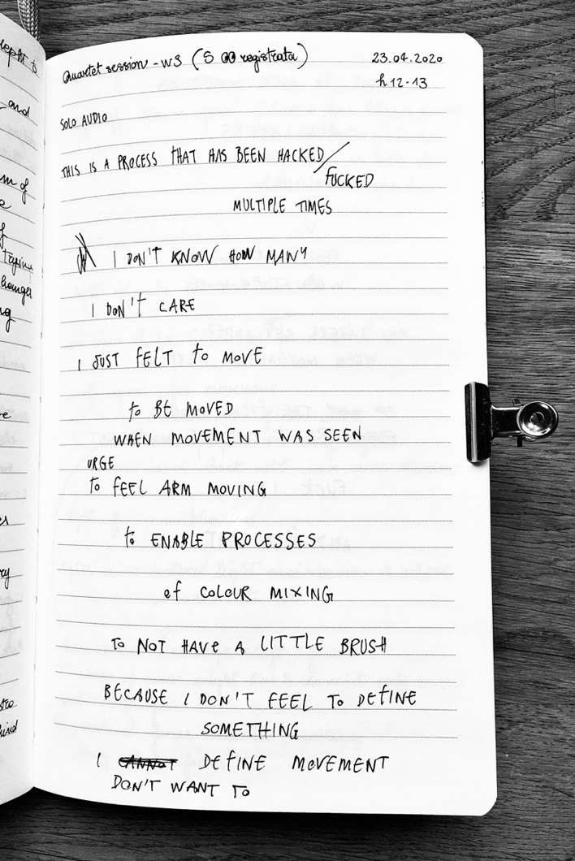

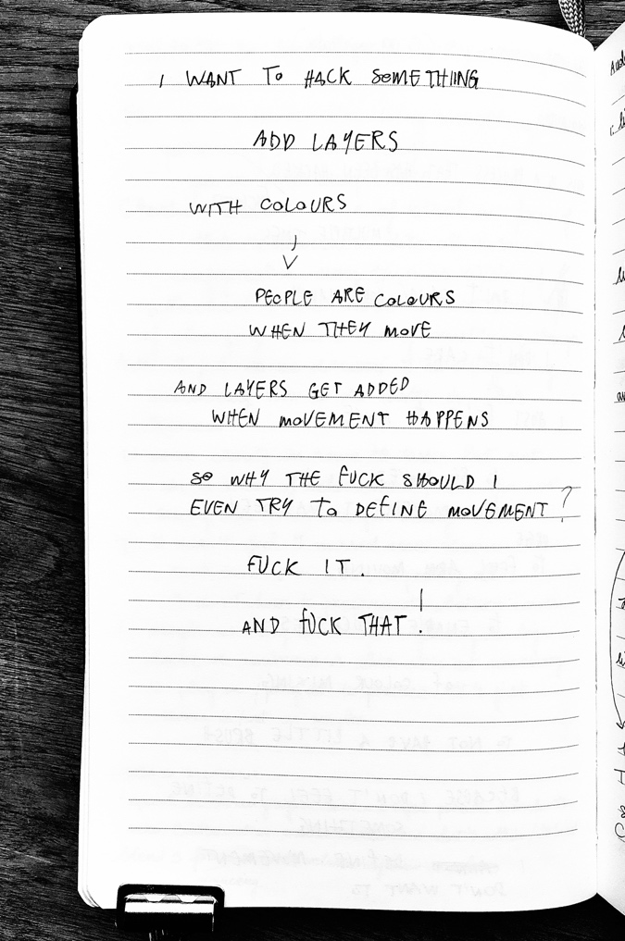

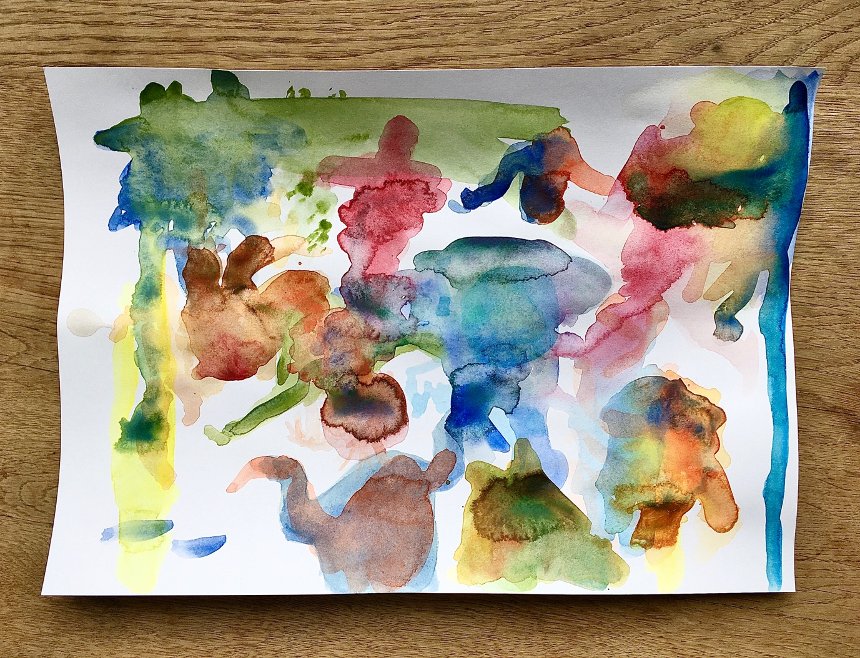

AUDIO ONLY

I: lights off. When on again: Charlie has Elisa’s shadow;
Eli has Arte’s shadow;
Arte has Tashi’ shadow;
Tashi has Charlie’s shadow.

Lights off only for Artè and Tashi.

When off again for Charlie and Eli, on again for Artè and Tashi.

Off again for everyone.

Lights on from above you, a perpendicular strong light beam and back with your own shadow in the room.

Lights off.

Lights on. This time a natural light and the shadow is where it’s supposed to be.

End of task.

I: How was this change of shift and focus?

T: I was working in one spot only, this might be due to the shape of the room.

C: A vertical focus was created; I was working closer to my body with a focus on the torso.

E: Hide and seek, I was always creating a shadow, doing / being 2 things at the same time, having 2 responses, 2 flavours.

A: I felt compressed, I had a friction with that light above my head and I was trying to escape with my shadow from underneath that beam.

I: make a note of what quality the fellow shadow has for you.

Now, on the light from above add the impossibility to add all of yourself to this source of light, how things don’t emerge / don’t add up. How the body is layered is erased in the shadow, there’s just a flat surface, there’s no verticality. Have a disagreement with this two-dimensionality of the shadow and the amount of overlap that exist in your body.

Light off.

Lights on just for Eli and Charlie.

Lights off for everybody.

Lights on, strong.

What’s your relationship with the shadow? Are you tied / glued to it? Are you it?
Does it command how you move? Is it commanding you because you’re trying to shape it?
Since the shadow it’s not a mirror but sums you up as a shape what do you need to do to be?
Is it diminishing you?
Does it mean you can disappear in this black hole of yourself / void?
Does it feel like an emptiness / lack of / a nothingness swallowing you or a rich combination of density supporting you from the ground up?
Knowing this is the same thing but what changes is how you approach to it, can you play with both?

End of practice.

Quote from a design book: “every accident provides a brief moment of awareness of real life, what is actually happening and our dependence on the systems [of design]”.
This is also related of my last period of craving accidents, risks and external provocations.

If our big body is a system, we can organise it in a way we can understand it. We’re sort of designing with our personal eye / shadow / thoughts the society of our body and a society as a combination of our bodies together. This creates a rapture / shock for the system that cannot function by doing the same things at the same time but the workload needs to be spread out. To sum up: some tasks are more universal, everyone understands in a similar way, other tasks each of you has designed them in a personal way.

T: I couldn’t agree with shadow as two-dimensional, I had to get away from it. For me shadow is 3D by principle, as the space around the body is actually part of the whole shadow too and just depends on how you lift it to do things. The shape might change but it’s definitely 3D and shadow and body are on the same level.

I: this disagreement for me is crucial. Proper shadow and carried shadow come together, opposite to what’s been said and defined.

C: I questioned the role of rhythm and dynamics in spatial tasks. I was trying to blur the lines among those tasks, sending mixed signals. It was a dialogue, monologue with my body.

A: I wasn’t much focused on shadow but more on light on surfaces, the image of water moving everywhere came out.

21.04.2020, h.15 -16

Charlie – Tashi – Artè – Elisa

In today’s practice there will be movers and readers.

Artè and Tashi will be reading a quote simultaneously while Charlie and Elisa will get on shadow task with light beaming from above.

A/T: I was giving space to not talk on top of each other.

C: the speaking voices moves the space.

I: where you moving with someone’s else voice the same way you move with someone else’s shadow?

C: the voice is perceived as a vibration, there was more turbulence than silence so the movement was more rhythmic.

E: for me the shadow task is fainter somehow today, I was more concentrated on try to build / create something and when the voice was coming in it was sweeping out what was created. As a “come on, just go back/ away.”

I: seeing movement as something is happening in thought process.
Now E/ C think as voice as shadows and move away from / towards it. So trickier when voices overlap.

This task is originated from how the medium we’re using and our mind work. Even though the sound is produced simultaneously, it’s not conveyed at the same time creating a void. Our brain compensates the gaps as one voice following the other to finish a sentence or repeat the last word.

E: I wasn’t listening to the meaning but the voices became movement / forms / possibilities rather than meanings. I was sculpting the sound in other forms.

C: the voices are entities of presence in the space around / with me. Thinking the voice as a shadow I was dancing my frustration on the impossibility of it. I was understanding while doing and doing while understanding the impossibility to interpret at the same time, so I end up doing nothing.

I: images that came in my mind to this frame of reference is the labyrinth, the abyss.

Swapping readers – movers: Eli / Charlie reading;
Tashi / Artè moving.

A: I remembered what I was reading but I wasn’t finding the fluidity I had when I was reading it, I heard it very machine reading.

E: even though I’ve the words in front of me, I couldn’t understand the meaning while reading.

I: probably because you were doing different things at the same time already, like listening to the other and overlap.

S: Question to Tashi: where you moving with your Butoh practice in mind as the body being moved, by voices as shadows in this case?

T:I wasn’t really thinking at Butoh but I wasn’t considering the shadows as moving towards / against them but rather as the shadows within me while I’m also shadow myself, blending, overlapping or distinctive from one or both. It’s a shift of perspective the way I see it.

